**Plant Callus Formation Protocol**

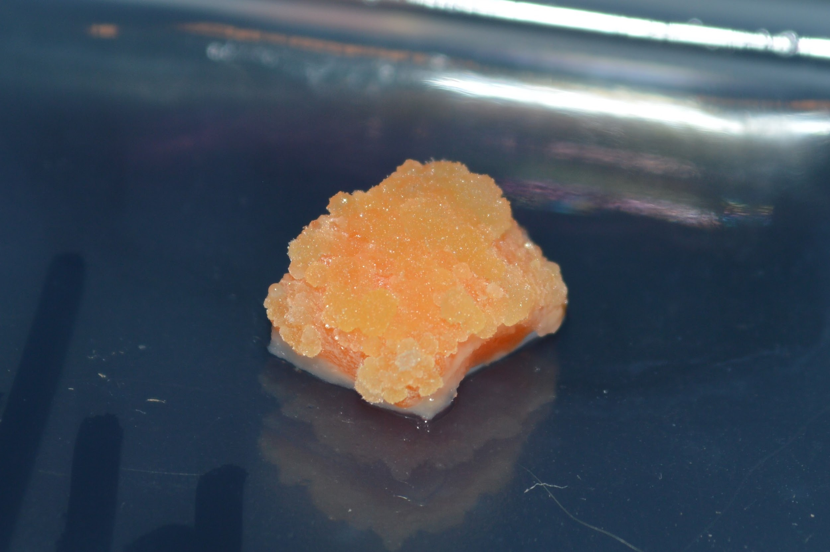

This kit has the materials to turn plant tissue in callus. The best plant materials to use are, in no particular order,

1. Leaf tissue from newly sprouted plants(cotyledons)
2. Leaf tissue
3. Root Tissue

For this guide we will use carrot root tissue which is the part of the carrot you normally eat!

The most important thing to remember is to be sterile. What does that mean? Bacteria and fungus are everywhere and the media material that turn the the plant cells into callus cells also grow bacteria and fungus. The bacteria and fungus will overtake the culture and the plant cells won’t grow well and turn into callus cells. Clean everything. Use isopropyl alcohol to clean your _GLOVED_ hands and the area that you will be working at. Make sure you clean and sterilize the the tweezers and razor blades before you use them. After things are sterilized do you best to not touch things that will be used to touch the plants even with your gloved hands.

Always wear gloves and Be sterile!



1 - MS Callus media (Half Strength Murashige Skoog agar vitamin media with 1mg / L 2,4D & 100mg / L Myo-inositol and 50mg / L Tetracycline)

1 - MS Root media (Half Strength Murashige Skoog agar vitamin media with 0.5mg / L IBA & 100mg / L Myo-inositol and 50mg / L Tetracycline)

1 - MS Shoot media (Half Strength Murashige Skoog agar vitamin media with 0.5mg / L Kinetin & 100mg / L Myo-inositol and 50mg / L Tetracycline)

1 - 250 mL glass bottle for pouring plates

1 - 50mL centrifuge tube for measuring liquid volume

14 - Petri Plates

5 - Pairs of Nitrile Gloves in plastic bag

1 - Tweezers

5 - Razor Blades

1 - Plastic Container

1 - Parafilm

Not Included but needed for Experiment:

1. Isopropyl alcohol
2. Bleach
3. Dishwashing soap
4. Distilled Water

# **protocolandwalkthrough.png**

# **Making Plates (~1 hour, maybe more time if it’s your first time)**

Step by step walk-through with photos at:<https://goo.gl/7yzpA1>

Agar plates provide a solid media nutrient source for plant calluses to grow on. The standard media that is used is MS (Murashige Skoog media). This contains a carbon source, a nitrogen source, micronutrients and vitamins.

The top part of the full plate has the larger diameter.

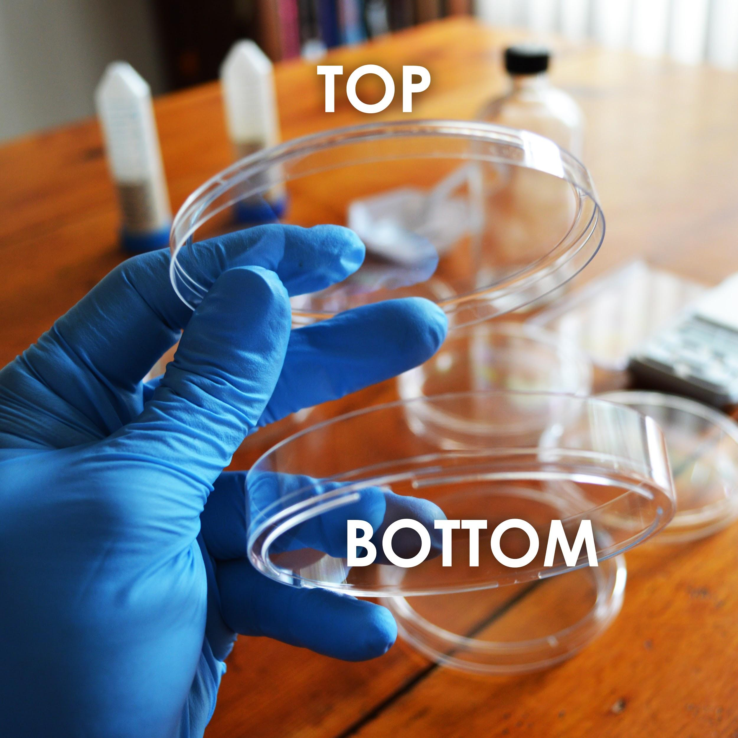

# ProtocolFooter.png

# **protocolandwalkthrough.png**

**Making Plates**

1. Take a tube labelled MS callus media and dump its contents into the 250mL glass bottle.
2. Using the 50mL conical tube labelled “For Measuring Water”, measure and add 150mL of water to the glass bottle.
3. Making agar is like making jello-- heat the agar to dissolve it, then it will solidify when it cools. Heat the bottle in the microwave for 30 seconds at a time, being careful not to let the bottle boil over. DO NOT SCREW THE LID DOWN TIGHT! (just place it on top and give it a slight turn)
4. You will know it’s done when the liquid looks clear. This should take about 2 -3 minutes total of microwaving. Take the bottle out(caution contents hot) and let it cool until you are able to touch it without much discomfort. This will take 20-30 minutes.
5. While the bottle remains somewhat warm, pour the plates. One at a time, remove the lid of 7 plates and pour just enough from the bottle to cover the bottom half of the plate. Put the lid back on.
6. Let cool for at least one hour before use(you can cool faster by putting them in the fridge but don’t freeze). If possible let the plates sit out for a couple hours or overnight to let the condensation evaporate. Then store in your fridge at 4ºC upside down so any condensation doesn’t drip on the plates.

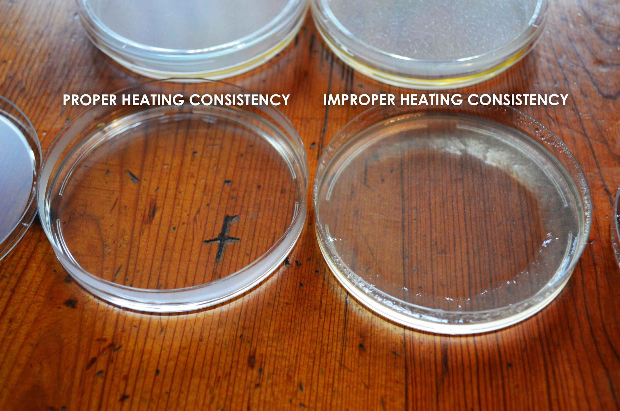

# **protocolandwalkthrough.png**

1. Take the carrot or plant tissue and wash it with soap and water.
2. Create a solution of 20% bleach by measuring out 40mL bleach and adding it to 160mL distilled water in the plastic container provided.
3. Take the tissue and put it in 20% bleach for 20 minutes
4. Soak the tissue in distilled water for 5 minutes 3 times. Do that by rinsing out the bleach container. Once it is clean add distilled water. Change the water after each 5 minute interval. This helps remove excess bleach that could damage the tissue.
5. Using a clean razor blade cut off a piece of carrot inside the skin it should be thin and small. It should be about the size of a pea. For leaves cut out a piece of leaf in the middle.
6. Place the pieces of carrot or plant tissue onto the media in your plates using sterile tweezers.
7. Place one piece on each side of the plate and then close the lid and seal by stretching parafilm around the lid. Place in the dark preferably in a box to limit air flow. Store at room temperature(20C-30C) for 15-40 days.

**Subculturing**

When the tissue starts turning into callus it should look like it has a bunch of little growths coming off of it. What you can do is divide this piece of callus tissue up for further experiments by cutting it using a sterile razor blade. You can then put the small pieces onto other callus plates to continue its growth.



Shoot and Root formation with Calluses